**GRANTS**

The BDS is an interdisciplinary group organized to promote social justice for vulnerable communities around mental health and social welfare. It was created during the tumultuous time of 2020 to address the need to heal community divisions and mental suffering in some small way.

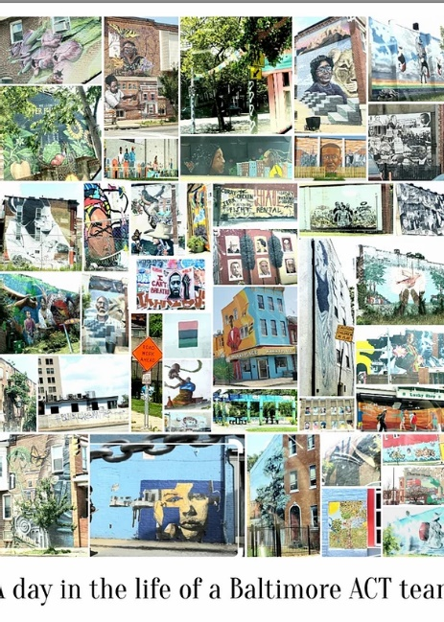

Our mission is:

To educate, organize community action, and advocate for policies that promote reducing behavioral health disparities, reducing racism, promoting human rights, and advancing social justice.

Our goals are to:

•Advocate for societal changes that will foster equity, eliminate racism, and promote the well-being of marginalized groups

•Reduce disparities in mental health by promoting social justice and human rights

•Apply principles of social justice to community action, systems change, education, policy formation, and clinical practice

•Understand the effect of social and cultural factors on the behavioral health of people in our community

We provide two awards to trainees: one to a Baltimore city public middle or high school student and one to a Psychiatry resident or medical student in Psychiatry in Baltimore. The awardees will be provided a mentor and a monetary award to support a project they propose to promote social justice in mental health in the community.

**Baltimore City Public School Students “The Future is Ours” Award**:

BCPS students in the 7th-12th grades can submit a proposal for a project that promotes equity for marginalized and underrepresented groups in Baltimore City around health/mental health and general wellbeing. Projects will need to take place during the school year and be monitored by a teacher. Grants will not be able to be awarded for computers, furniture, transportation, or prepared food. Awards can be from $100-$400 and includes monthly mentoring by a professional and leader in the community on the area of work proposed for up to 6 months. The award may also include an opportunity to shadow a mental health professional in their work to ensure that historically disadvantaged and marginalized individuals have access to culturally sensitive comprehensive treatment in the community for a day. Deadline: Rolling.

**Psychiatry COVID19 Disparities Award:**

Medical students rotating in Psychiatry or Psychiatry Residents who studied Psychiatry in Baltimore City can submit a proposal for a project that specifically addresses disparities in health equity, access to care, institutional distrust and other barriers, and poorer outcomes around COVID19 morbidity and treatment for marginalized and underrepresented black and brown communities in Baltimore

City. Projects will need to take place while trainees reside in the area. Grants will not be able to be awarded for computers, furniture, transportation, attendance at professional meetings, or subscriptions. Awards can be from $100-$400 and includes monthly mentoring by a psychiatrist and leader in the community on the area of work proposed for up to 6 months. The award may also include an opportunity to shadow a psychiatrist in their work to ensure that historically disadvantaged and marginalized individuals have access to culturally sensitive comprehensive treatment in the community. Deadline: Rolling.

**Grant Award Application**

___ Baltimore City Public School Students “The Future is Ours” Award

___ Medical Student/Resident COVID19 Disparities Award

Student(s)/Trainee(s) Involved and grade/post graduate year:

1. Primary-______________________________________________________________
2. _____________________________________________________________________
3. _____________________________________________________________________
4. _____________________________________________________________________
5. _____________________________________________________________________

Supervisor/Supervising Teacher’s Name and Position/title: _____________________________________________________________________________

Supervisor/Teacher’s Signature:___________________________________________________

Supervisor/teacher’s email: _______________________________________________________

School Name and Address: ______________________________________________________________________________ ______________________________________________________________________________ ______________________________________________________________________________

(For BCPS Students)

Principal’s Name: ______________________________________________________________

Principal’s signature: ___________________________________________________________

Title of Project: _____________________________________________________________________________

Specifics of project including creative aspects: ______________________________________________________________________________ ______________________________________________________________________________ ______________________________________________________________________________ ______________________________________________________________________________ ______________________________________________________________________________

What do you expect the project to accomplish? ______________________________________________________________________________ ______________________________________________________________________________

______________________________________________________________________________ ______________________________________________________________________________

Long-term benefits: ______________________________________________________________________________ ______________________________________________________________________________ ______________________________________________________________________________ ______________________________________________________________________________

Total amount of money required: __________________________________________________

Itemized list of proposed purchases including costs: ______________________________________________________________________________ ______________________________________________________________________________ ______________________________________________________________________________ ______________________________________________________________________________ ______________________________________________________________________________ ______________________________________________________________________________ ______________________________________________________________________________

Amount of money received from other sources: ______________________________________________________________________________ ______________________________________________________________________________

Directions

Submit to: Theodora Balis, MD- [bdsmhsj@gmail.com](mailto:bdsmhsj@gmail.com). Phone-410-916-4890. Applications will be reviewed and decided within 30 days from receipt.